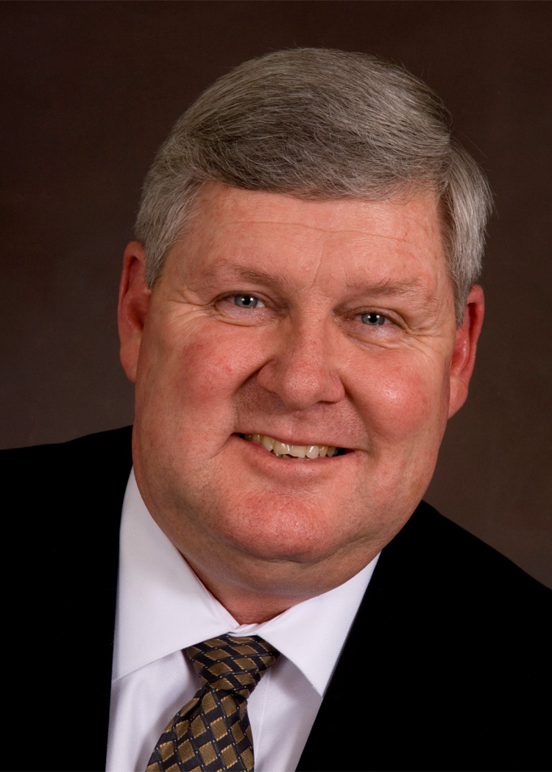

John D. Butler, CBE
Vice President
Naval Strategic Systems

John D. Butler commenced his current assignment at Lockheed Martin Space Systems Company (SSC) in September 2008. He manages SSC’s Washington, DC office and serves as the SSC interface with the U.S. Navy’s Strategic Systems Programs and Lockheed Martin Washington Operations. He is also responsible for UK Strategic Systems and Navy integration relative to LMUK-SS business at Her Majesty’s Naval Base Clyde, which includes Strategic Weapons Systems base operations for the Vanguard class SSBN at Faslane and the Royal Navy Armaments Depot (RNAD) at Coulport. John is the SSC member of the ABL Alliance Governance Board for RNAD Coulport.

He joined Lockheed Martin Maritime Systems & Sensors (MS2) in September 2005, where he was Vice President and Chief Technologist for Undersea Systems. In February 2006, John became Vice President of Programs for MS2 Littoral Ships & Systems and was the on-site executive in Marinette, Wisconsin in charge of construction of the Littoral Combat Ship, USS Freedom (LCS 1). He also served as MS2 Vice President and Senior Advisor for Naval Affairs. John joined Lockheed Martin after completing a 31 year career in the Navy as a Submariner and Engineering Duty Officer.

John retired from the U.S. Navy in September 2005 as a Rear Admiral. He had a successful career in submarines, starting with service on USS Will Rogers (SSBN 659) and ending as the Program Executive Officer (Submarines). He was the Navy Acquisition Executive responsible for design, construction and acquisition of undersea systems, including nuclear-powered submarines, submarine combat systems, submarine information and electronic sensor systems, undersea weapons, special operations systems and surface ship torpedo defense. During his 31 years of service, his submarine expertise was provided to the UK for the Vanguard class SSBN and Astute class SSN submarine programs, as well as to the Australian Collins class program.
A native of Texas City, TX, he received his Bachelor of Science degree in Chemistry from the University of Texas at Austin in 1974 and his Masters of Science degree in Engineering Acoustics from the Naval Postgraduate School in 1986. He is also a graduate of the Executive Business Course at Naval Postgraduate School; the Management Program for Executives at the Katz Graduate School of Business, University of Pittsburgh; the Professional Summer at the Massachusetts Institute of Technology; and the Advanced Program Managers Course at Defense Systems Management College.

He was awarded his CBE (Commander of the Most Excellent Order of the British Empire) by Her Majesty Queen Elizabeth II in 2010 for his support of the Royal Navy’s Submarine Flotilla.

John is the Lockheed Martin Focus School Corporate Executive for the University of Texas at Austin and serves as a member of the College of Natural Sciences Advisory Council, Chancellor's Council, Commission of 125, Littlefield Society and President’s Associates at the University of Texas at Austin. He has been honored as a Distinguished Graduate of the University of Texas at Austin. He also serves as a member of the Board of Directors for the U.S. Navy Memorial; as a member of the Advisory Board of the National Defense Industrial Association - Undersea Warfare Division; as a member of the Advisory Board of the CAVALLA Historical Foundation; and as an Admiral in the Texas Navy.

