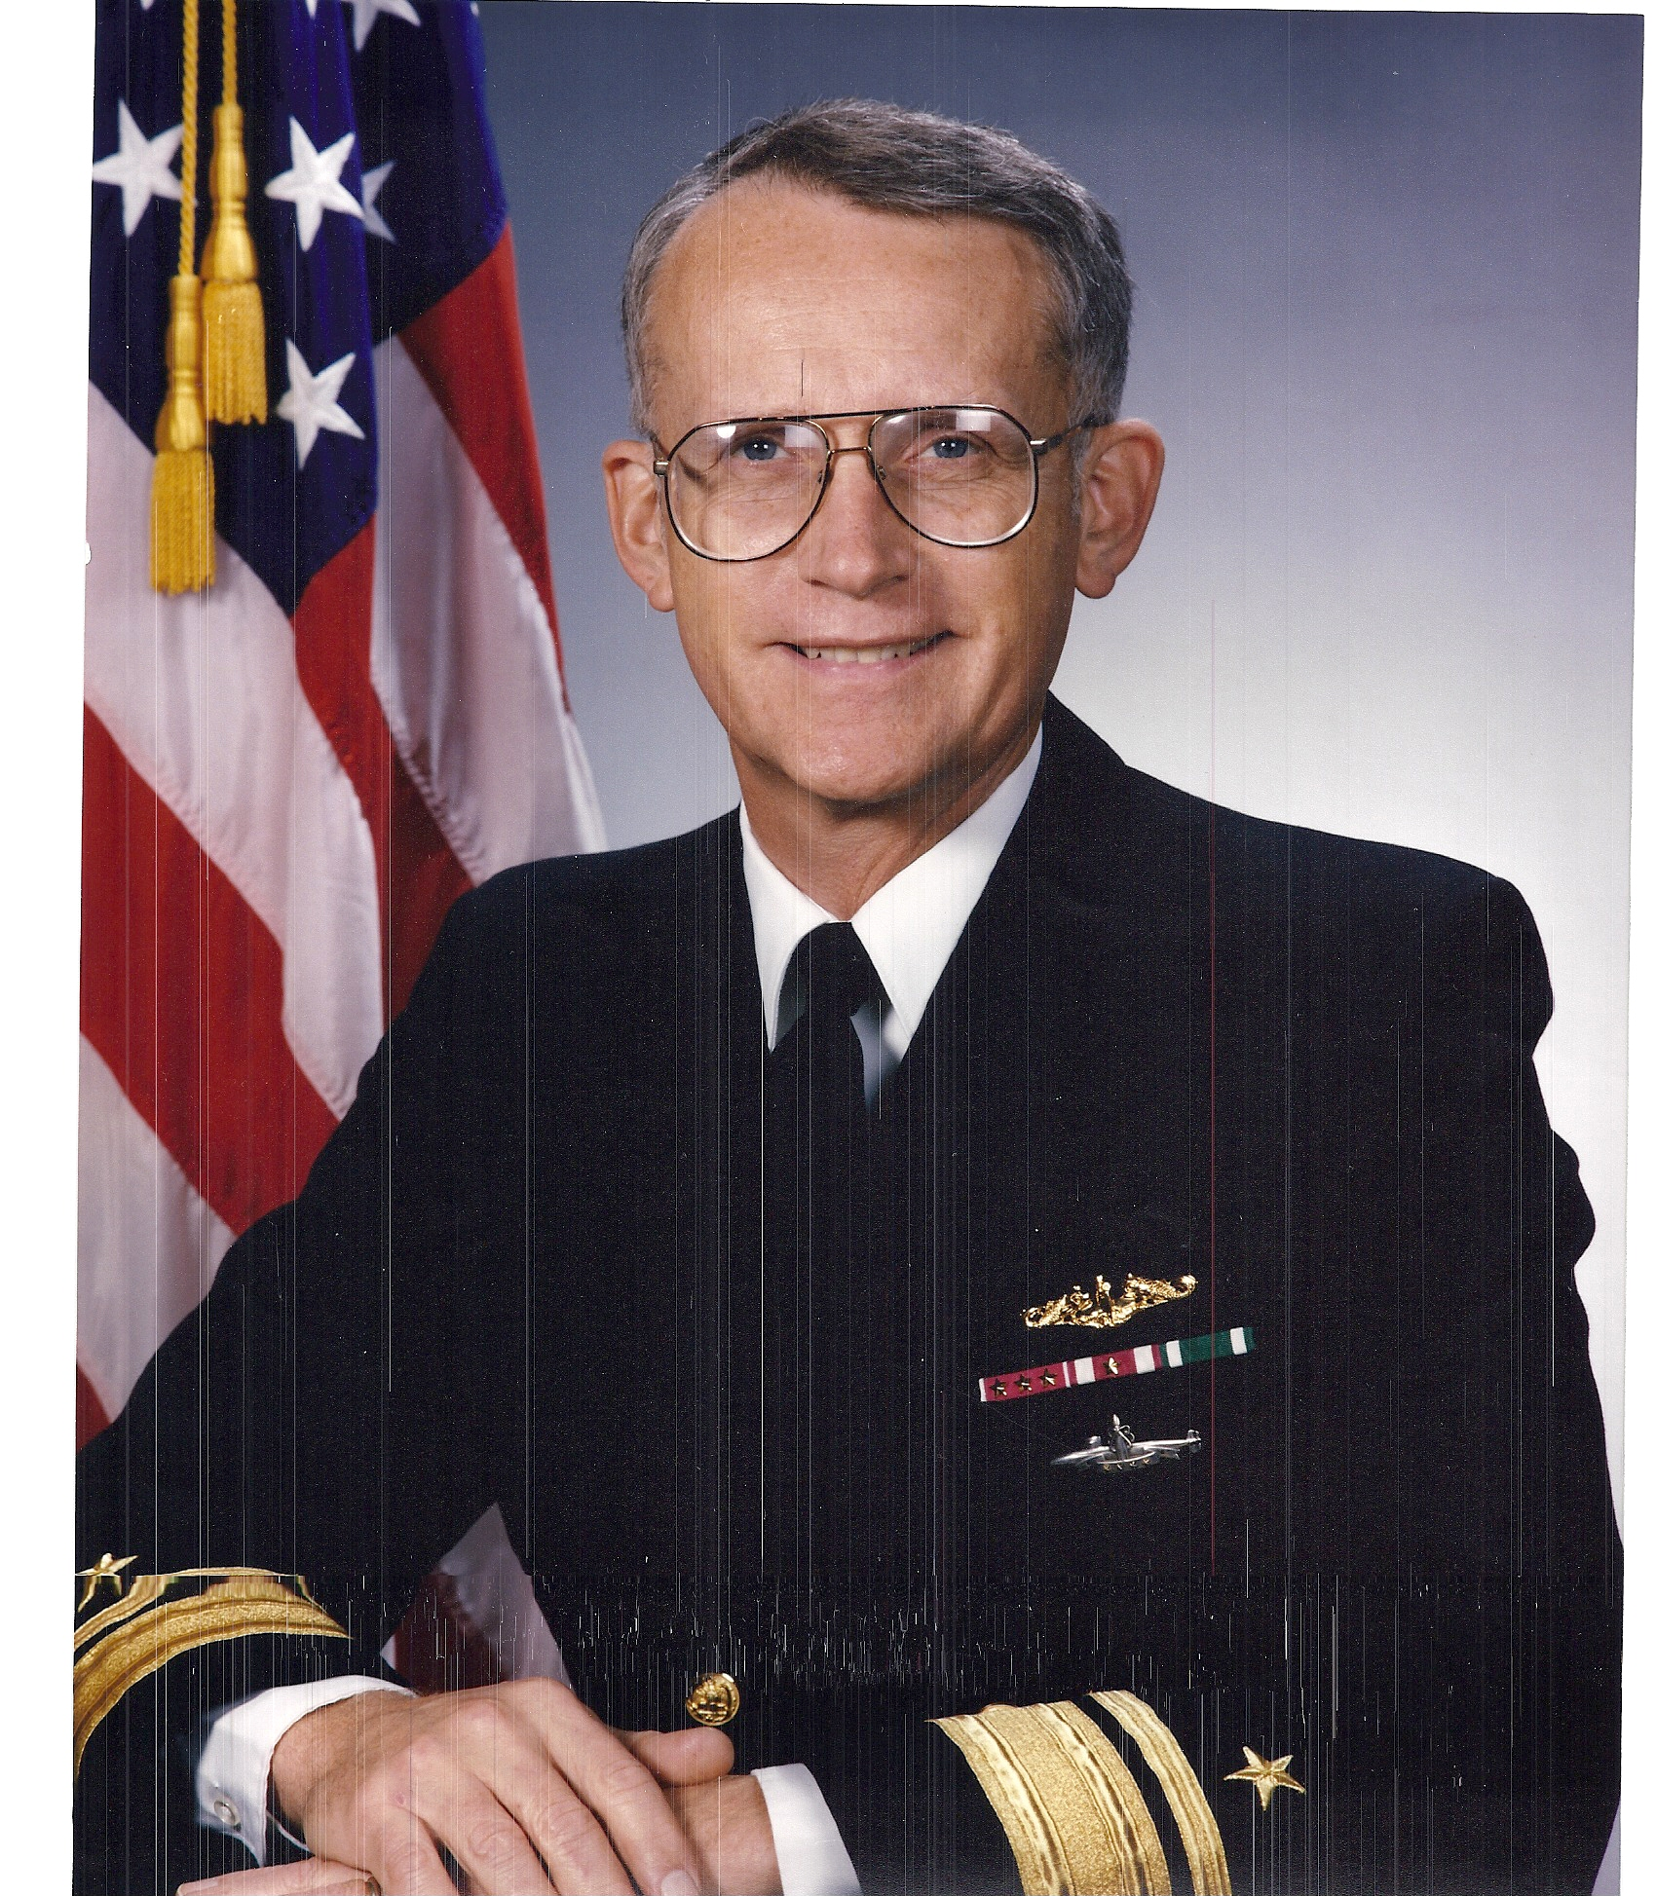
Rear Admiral Marsh is a native of Chicago and
the son of Mr. and Mrs. Malcolm E. Marsh. He
graduated from the United States Naval
Academy in June 1963 and immediately entered
nuclear power and submarine training. In
February 1965, he reported to his first subma-
rine, USS CUBERA (SS 347), serving on board
as Assistant Engineer and Weapons Officer

until July 1966. He was then assigned to USS
FLASHER (SSN 613), where he served as
Supply Officer and Damage Control Assistant.

In 1967, Rear Admiral Marsh was selected as a Navy candidate for a postgradu-
ate Olmsted Scholarship under cognizance of the Department of Defense. From
1968 until 1970, he studied German, Political Science, and International Rela-
tions at American University in Washington, D.C. and the University of Munich

in West Germany. In August 1970, he reported to USS BILLFISH (SSN 676) as .
Navigator, where he served until December 1973. In April 1974, following
advanced training, he reported aboard USS CASIMIR PULASKI (SSBN 633)
(GOLD) as Executive Officer. In January 1977, he entered submarine
Prospective Commanding Officer training. He then commanded USS WILL
ROGERS (SSBN 659) (GOLD) from July 1977 to March 1981, completing 7
submerged strategic deterrent patrols in command.

Following command, Rear Admiral Marsh served as Head, Submarine Nuclear
Power Branch in the Naval Military Personnel Command in Washington, D.C. In
August 1983, he was selected to serve on the Chief of Naval Operation's
Strategic Studies Group at the Naval War College in Newport, Rhode Island. In
June 1984, he reported to the Pentagon where he served as Executive Assistant
to the Director, Naval Warfare. In June 1986, Rear Admiral Marsh assumed
command of Submarine Squadron TWO in New London, Connecticut, where he
served until April 1987, when he was selected for assignment as Chief of Staff,
Commander Submarine Force, U.S. Atlantic Fleet in Norfolk, Virginia. In
December 1988, he was selected for promotion to Rear Admiral (Lower Half),
and, in March 1989, he was assigned as the Director, Program Resource
Appraisal Division on the staff of the CNO.

Rear Admiral Marsh relieved as Commander, Submarine Group NINE and
Commander, Naval Base Seattle in September 1990. He was selected for
promotion to Rear Admiral (Upper Half) in March 1992, and, in July 1992, he
reported as Director, Office of Program Appraisal in the Office of the Secretary of
the Navy, where he served until May 1994. At that time, he was ordered as
Assistant Chief of Naval Personnel for Personal Readiness and Community
Support, where he served until June 1997. He was then reassigned as Deputy
Chief of Naval Personnel, where he served until his retirement on 1 July 1998

following 35 years of active service

In retirement, Rear Admiral Marsh served first as Executive Vice President, then as President and Chief Executive Officer of The George and Carol Olmsted Foundation in Falls Church, Virginia. He retired from The Foundation on 1 May 2011.
Rear Admiral Marsh is married to the former Barbara Ann Rhea of Baltimore, Maryland. They live at Lake Frederick near Front Royal in Virginia’s Shenandoah Valley.

Rear Admiral Larry R. Marsh,
U.S. Navy, Retired

