Dr. Barbara Pilling
April 2016
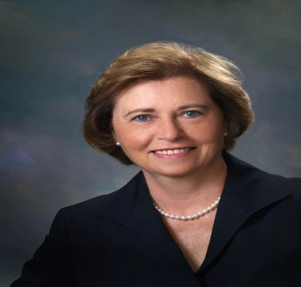

Dr. Barbara Pilling is a Senior Research Associate at the Applied Research Lab at Penn State University. Her area of expertise is STEM (science, technology, engineering, mathematics) education research with an emphasis on diversity program success. Dr. Pilling completed a study for the Office of Naval Research, HBCU/MI Program Office in 2013, RESEARCH GUIDE FOR DIVERSITY PROGRAM SUCCESS, and another study in 2016, A FEASIBILITY STUDY ON UNDERGRADUATE RESERCH PROGRAMS. A further area of expertise is program evaluation. She supported NAVSEA and NAVAIR diversity programs focusing clients on establishing outcomes and determining strategies for successful program evaluation.

Dr. Pilling brings diverse leadership talent as an experienced educator and administrator focused on both the instructional and business sides of education systems. She has a broad background in teaching, administration, and curriculum development. As a teacher she taught mathematics at the elementary, middle, and high school levels; as an administrator, she managed large teams of faculty and staff including those in mathematics, science and technology departments; as an adjunct professor, she taught master's level courses to practicing mathematics teachers; and as a consultant, she developed mathematics courses and structured online classes for adult learners.

Dr. Pilling has been a frequent presenter at national professional association conferences, and has served as a Grant Reviewer for the Department of Education. She developed training modules and coordinated in-services for teachers and staff; managed large-scope district-wide administrative reorganizations; and served on special councils and curriculum review committees. Dr. Pilling served as the Minority Achievement Coordinator at several schools and initiated and developed multi-faceted diversity and mentoring programs.

Barbara Pilling has been an active volunteer to military organizations throughout the years. She served as the President of the Society of Sponsors of the United States Navy 2013-2015, and currently is a Trustee and Finance Chairman. She also serves as a Director for the Naval Historical Foundation and initiated and helped develop the STEM Teacher Fellowship Program. An area of interest is helping to connect Navy history and heritage with relevant STEM education. Barbara Pilling was a Navy spouse for 42 years and has a deep appreciation and understanding of Navy life.

